Prerequisites -3

|  |  |
| --- | --- |
| Team ID | PNT2022TMID43975 |
| Prerequisite | Clarifai account |

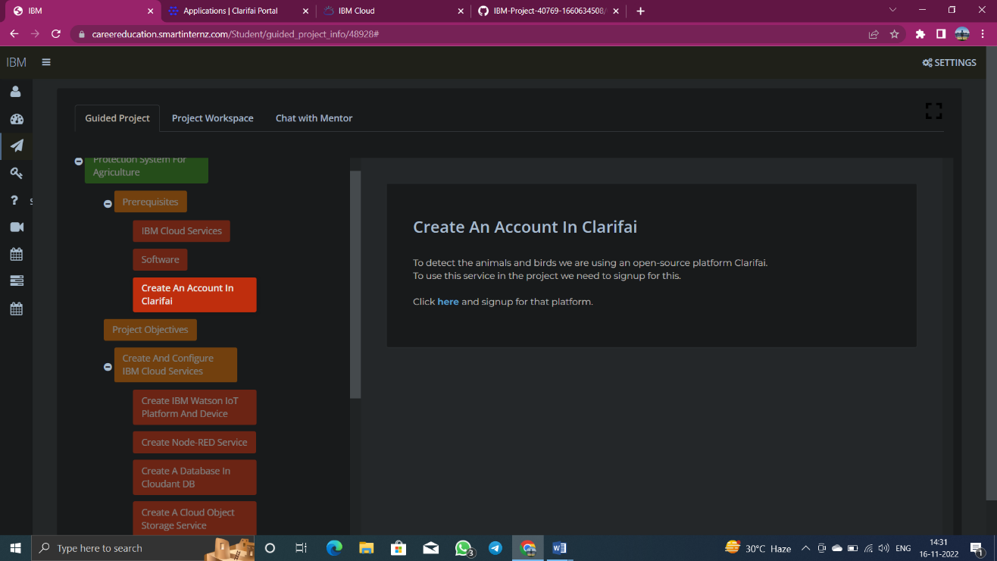

Signup Page:

